October 24, 2021 Mark 10:46-52
“What Are You Lookin’ at?”

Sometimes it is hard to discern what it is right in front of you. For example, what do you see here?
If you look at it one way you see chess pieces…if you look at it the other, you see people who are bowing their heads to each other. There is more here than one imagines. How about this one?
If you look at it from a distance – you see a particular pattern repeating…but take a moment and choose just one dot. Follow that dot and that dot only and what do you see? Something quite different isn’t it?

The next picture also has elements which mislead us - what do you see?
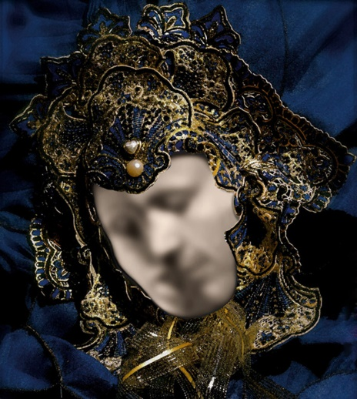
The outline of the mask leads us to see a fuzzy person…perhaps this is a death mask…But if you look again – you can see a couple beginning an intimate kiss. One way of looking at it is rather grim and the other portrays a positive happy moment. What we see is often determined by cues and circumstance which we imagine to be incidental – but can be crucial to our understanding.

In our text today we see people in the story about whom the setting can lead us to think about one way – and a close look can tell us something else entirely.

Jesus and his disciples are entering Jericho. The association of his followers with Jesus leads us to believe they are the ones who understand who Jesus is and what he is all about. And then we are introduced to Bartimaeus who is described as a blind beggar. Now – off the top of your head – which character do you want to be and identify with…why a disciple of Jesus – of course. And who is the character who is in trouble and you wouldn’t want to trade places with them for anything? The blind beggar. And you are thinking – ask me something hard…this is the easiest quiz I have ever taken!

But as our scene plays out what do we discover? We discover that those closest to Jesus don’t have a clue. The crowds who are watching are only there for the show. And the blind beggar is the only one who seems to know what is going on.

We thought we were looking at people – and they were chess pieces. On the way to Jericho the disciples argued over who is the greatest – and Jesus told them they were misguided. Leaving Jericho, the blind beggar annoys people in his effort to get help from Jesus. Those who came to watch the parade and perhaps gather in some of its reflected glory tell him to pipe down – he is ruining the ambience…and Bartimaeus just yells louder. Such holy persistence. And he is rewarded. Holy persistence pays.

Bartimaeus leaps to his feet, throws off his cloak, and runs to Jesus. That seems simple enough – but there is more – In throwing off that cloak – what seems like an incidental action – we see that Bartimaeus is “all in.” Why would Mark bother to tell us he threw off the cloak? Mark is the shortest gospel filled with conflict and action – he doesn’t tell us anything which could be left out.

The cloak has at least two possible meanings – the first is that it is how he collected the coins people gave in response to his begging. He spread the cloak out and people would toss the coins on the cloak. In leaving it behind – he is all in believing he won’t need it anymore. Leaving the robe behind is an act of faith. Another possible meaning is that his name means “Son of Timaeus” and the Timaeus was a philosophical work in the ancient world which would have provided a way of understanding life. In the ancient world it was also true that disciples of a teacher wore robes which marked them as followers of that teacher. So, it is possible that Bartimaeus is not only “all in” believing Jesus will heal him and he won’t have to beg – but his is also “all in” believing that Jesus and not the Timaeus will show him the way to life. It is a deep and radical act of faith even before he gets to Jesus.

And when he gets there, what does Jesus do? He asks a question. Perhaps Jesus seems a little slow on the uptake here – a blind man has stopped you and asked for mercy – what did you think he was going to say? But Jesus knows this moment is important. It is crucial that Bartimaeus consider the question, “What do you want me to do for you?” And it is crucial for us as well.

To live a life of faith is not simply about keeping our heads down and avoiding bad things. To live a life of faith is about looking deep inside – and discovering an answer to Jesus question. It takes courage. But it is an act of faith. To know Jesus is the one to whom we go for life, for courage, for love. To believe we are accepted enough to be able to say what is really true deep down for us. What do you want as God’s child? It is an important question to consider since Bartimaeus is the model for what it means to be a disciple in our story.

God surprises us – a lot. The person we thought was no more than an object of pity turns out to be the one Jesus wants us to be like. One who is persistent in pursing blessing in the person of Christ – one who does not hedge bets but trusts in God’s mercy – one who learns from life experience and follows Jesus on the way. That’s the person Jesus wants us to be like.

We can’t always be sure what we are looking at – but we can be clear about the one to whom we go to sort things out. Each of us has some sort of blindness. And it is Jesus who helps us to truly see. God help us to know in everything which is most important, what we are looking at.

